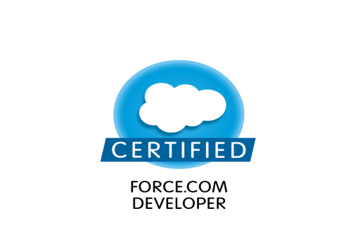

**ANNAVARAPU VISHNU**

**Mail id**:vishnu4k7@gmail.com

**Contact N**o: +91 8185961719

**CAREER OBJECTIVE**

To become a successful professional in the field of Software engineer and to work in an environment where I can utilize my Knowledge for fulfilling organizational goals.

**SUMMARY**

* Level Of understanding of Salesforce.com CRM and its Development Life Cycle and Certified as Platform Developer 1 (pd1)
* Ability to Creating SFDC out of box functionalities like Apps, objects, fields, tabs, profiles based on Business Requirements
* Having Knowledge on Record Type Pages,Page Layouts and Relation Ships.
* Good knowledge with providing Security Controllers to users By using Profiles,Roles,Permission Sets and OWD Settings
* Good Knowledge on Creating Reports and DashBoards.on Business Reruirements.
* Having Knowledge on Implementing Validation Rules ,Workflows Rules and Assignment Rules.
* Ability to work with DataLoader, Import Wizard and Sand Box Environments.
* Knowledge On Implementing Apex classes, Visual Force Pages and Triggers.
* Having Good Knowledge in Database languages like SOSL and SOQL.

**CERTIFICATION**

<http://certification.salesforce.com/verification?&fullname=vishnu%20annavara>

**PROFISSIONAL PROFICIENCY**

* **CRM :** Sales Force CRM
* **SFDC Technology :** Apex Classes, Visual force Pages and Apex Triggers.
* **Programming Languages :** Core Java,Apex,Visual Force.
* **Sales Force Tools :** Eclipse, Apex Data Loader **.**
* **Web Technologies :** HTML, VisuvalForce
* **Data Base :** SOQL, SOSL**.**
* **Operating Systems :** WINDOWS 2000, XP,7,8.1,10.

B**ASIC ACADEMIC CREDENTIALS**

|  |  |  |  |  |
| --- | --- | --- | --- | --- |
| **Qualification** | **Year** | **Institution** | **University/**  **Board** | **Percentage** |
| B.TECH | 2017 | QIS College Of Engineering & Technology | JNTU, Kakinada | 72% |
| INTERMEDIATE | 2013 | NRI Junior College | State Board Of Education  AP | 93% |
| SSC | 2010 | Geethanjali High School | Board of secondary education | 88% |

**ACHIEVEMENTS**

* Won first prize in quiz compitation in the collage fest
* Won second prize in running in the school sports.
* Won second price in paper presentation.

**INTERPERSONAL SKILL**

* + Good Listener
  + Ability to rapidly build relationship and set up trust.
  + Confident and Determined
* Willingness to learn, team facilitator and hard worker.

**PERSONAL DOSSIER**

* **Father’s Name :-** A,Srinivasa Rao
* **Date of Birth :-** 30-03-1996
* **Language Known :-**  Telugu, English
* **Marital Status :-** Single
* **Nationality/Religion :-** Indian
* **Interest & Hobbies :-** Listening music and playing cricket.

**DECLARATION**

I do hereby declare that the above information is true to the best of my knowledge**.**

**Date::**

**Place:: Signature**

**(A.Vishnu)**